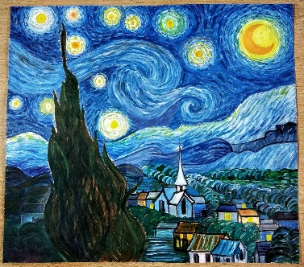

The Icarus Arts Society Year Plan



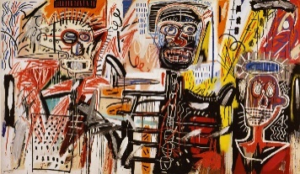

***To be Icarus...*** “So much to do, so little done.”  
Prisoners of King Minos. Prisoners of society. We, Icarus and I are trapped along with those that raise us. For him, that’s Daedalus, his father. For me, that’s my ambition. They create what we need to escape the chains society feels we need placed on our psyche. Our fathers and ambitions, make for us wings, with which we feel the tinge of stardom as we soar leagues overhead. Wanting more, our fathers, ambitions, tell us to pace ourselves, to not go too far in too short a time. To not fly too fast to the point we’re out of sight. To not fly too high up in the sky, lest our wings of ambition, dreams and drive decide to burst in flames and let the flame within us die out. Going up in flames, Icarus comes crashing down like a shooting star into the glistening sea of regrets and realizations. Gulping on, “art doesn’t pay”, swallowing, “you can never make it”, suffocating on, “you’re not good enough”, We, Icarus and I begin to realize it’s not that deep. For like phoenixes from the ashes, we can be raised again, and we will, for unlike Icarus, as artists we are given the chance to try again, this time with the understanding, “tot facienda parum factum.” So much to do, so little done.

Icarus Society Year Plan

Regular Activities

Words to the World (Radio Show)

A spoken word radio segment where poets from the Society perform their work on NUST Radio.

Occurs twice a month.

Provides exposure for poets and allows them to share their art with a wider audience.

Weekly Poetry Readings

Every Tuesday, poets perform their poetry in front of a live audience.

Encourages public speaking skills and engagement with the community.

Open to all Society members interested in spoken word performances.

Blog Publication

A blog dedicated to publishing written works by Society members.

Different writers contribute weekly.

Covers various forms of writing, including poetry, essays, and creative fiction.

Major Events

Annual Fashion Show

A large-scale event showcasing the creative fashion designs of Society members.

Held once a year.

Includes runway presentations and collaborations with designers and stylists.

Art Exhibitions

Held at the Society’s venue to showcase and sell various forms of art.

Open to all art forms, including painting, sculpture, digital art, and mixed media.

Provides artists with the opportunity to gain recognition and financial support.

Art Galleries for Visual Arts

Organized at different intervals throughout the year.

Focused on the visual arts, featuring curated displays from emerging and established artists within the Society.

Offers networking opportunities with local and external art communities.

Performative Arts Show

A full show once per semester for performing artists, including theatre, dance, and music performances.

Allows students to showcase their work in a dedicated performance setting.

Encourages interdisciplinary collaborations among creatives